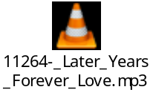

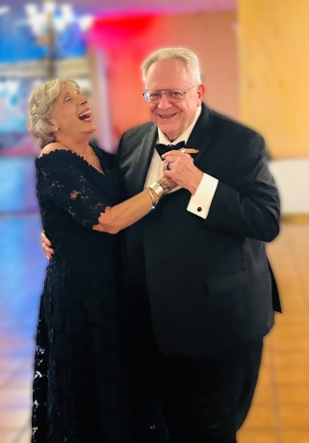

We grew up in the same old days, baby boomers side by side,
Life moved fast, and time moved on, with so much we had to hide.
You walked through loss, a widower, learning how to breathe again,
And I did too, a widow’s heart, carrying the weight of pain.
Then somehow love found room to land, in a season we didn’t plan,
Two souls a little older, still believing we still can.
You make me smile like it’s brand new, like the sun after the rain,
And I thank life for bringing you, after everything we’ve seen.

In these later years, you’re my love, you’re my happiness,
I hold your hand and I feel my heart find peace in this.
Armand, I’m yours—always and forever, it’s true,
No matter what tomorrow brings, I will choose you.

We don’t need perfect stories, we don’t need to rewrite the past,
We just need this gentle love, the kind that’s built to last.
A quiet dinner, soft goodnight, the comfort of your voice,
The simple way you look at me, like loving me’s your choice.
We’ve learned what really matters, after storms and sleepless nights,
Now we build a little home where everything feels right.
You’re not just someone I found—you're the one I’m grateful for,
The kind of love I waited on, the one worth waiting for.

We’ve both known goodbye, and we’ve both known tears,
So this love is precious, and it’s so clear.
I’m not afraid to say it, I want you to stay,
I’m yours for life—on Valentine’s Day and every day.

In these later years, you’re my love, you’re my happiness,
I hold your hand and I feel my heart find peace in this.
Armand, I’m yours—always and forever, it’s true,
No matter what tomorrow brings, I will choose you.

We found our love when we needed it most, and it feels so right,
Armand, always and forever—my heart is yours tonight.

